Mouse management (Ver 1.0)

Introduction

This is the web application that allows users to manage their ended mouse. Upon accessing the website, the app is ready to be used without further initialization. In this mouse management, users allow to insert, update the end mouse as well as uploading related mouse images to the server.

In current version, deleting of mouse and images are supported. It will be added into the website in the future.

Software Detail

Python server dependency

1. Django – ver. 2.0.6
2. Pandas – ver. 0.23.1 , numpy – ver. 1.14.5, dateutil – ver. 2.7.3, six – ver. 1.11.0
3. Mod-wsgi – ver. 4.6.4
4. Django cors headers – ver.2.2.0

Angular Cli – ver.6.0.7

Manuel

1. To insert a mouse, firstly open the insertmouse panel on the right top corner of the table.

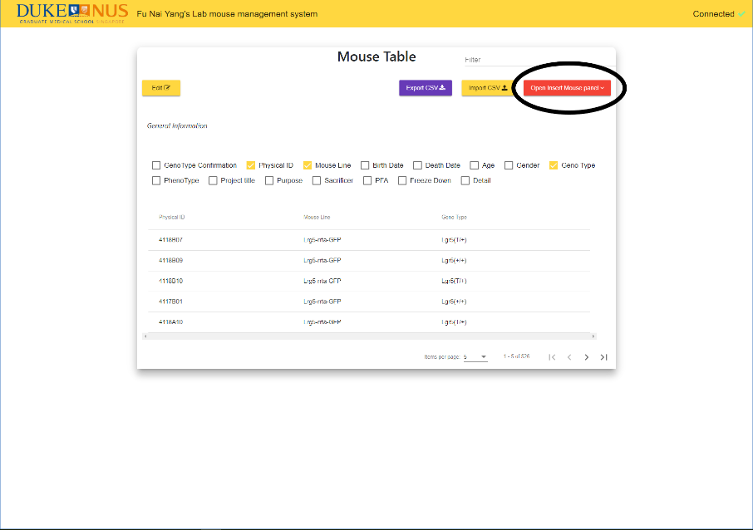

The insert mouse panel will appear at below. Scrolling down the page to see the panel.

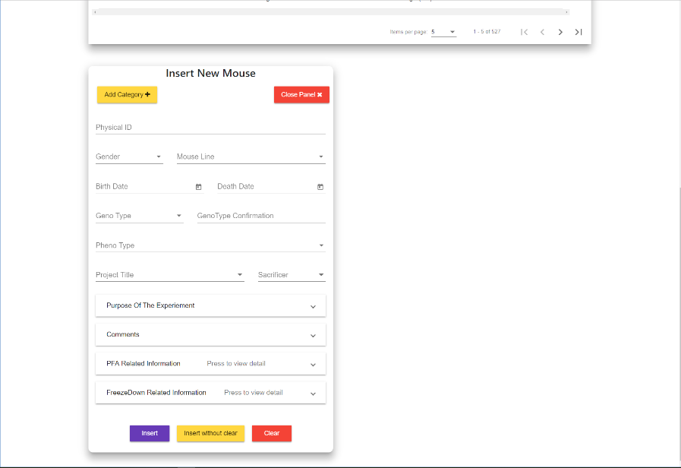

Notes:

All the inputs must be present except Comments, PFA Related Information, FreezeDown Related information.

After Inserting the particular information, by clicking the insert button to confirm and insert into the database. In the other hand, by default, it will clear the inputs upon successful insertion. If user would like to not to clear the inputs and prepare for next insertion, user can click the insert without clear buttons.

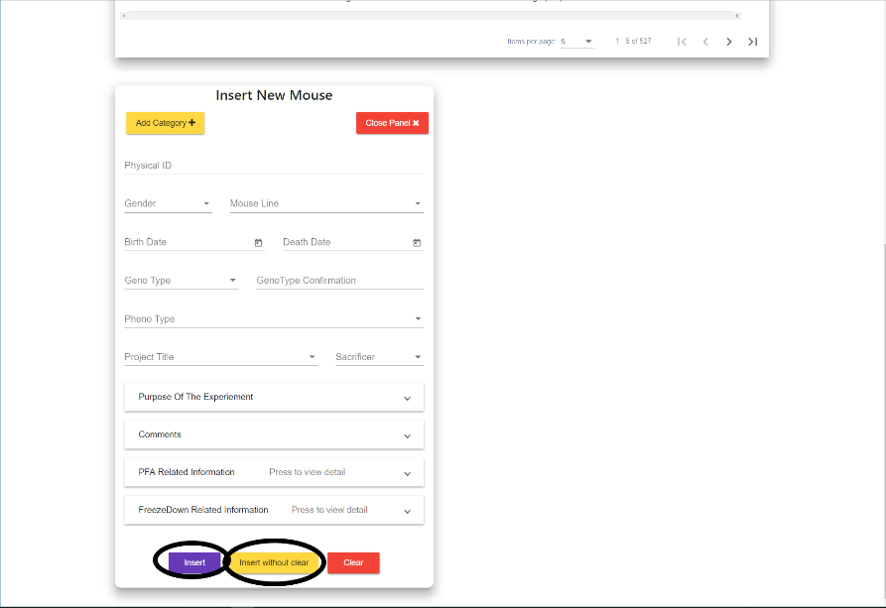

1. Regarding to the table view, the default columns are Physical ID, Mouse Line and Geno Type. Users are free to on and off the columns based on user’s preferences.

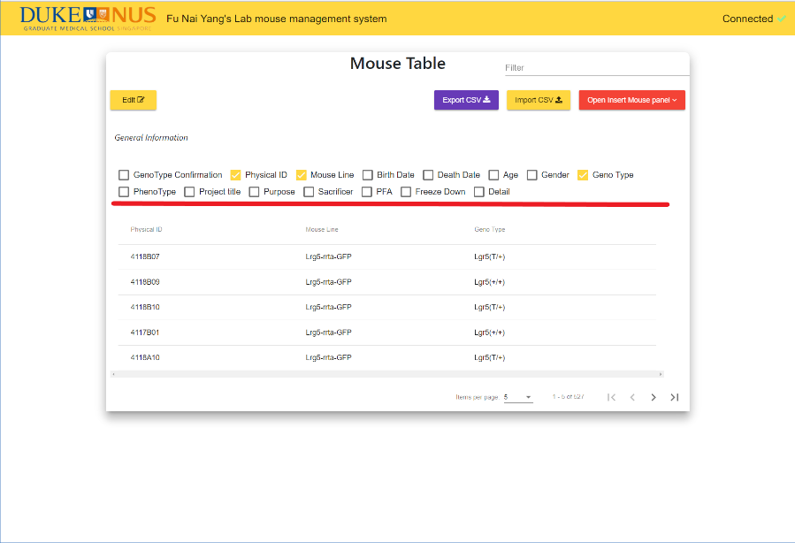

Moreover, users can sort the table based on the type of the data in each of the columns by clicking the column header.

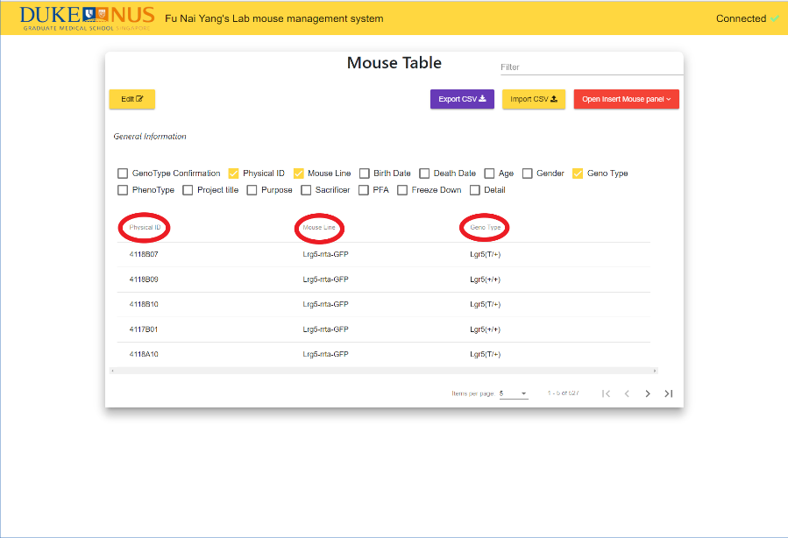

Besides the turning on and off the columns and sorting of columns, users can use filter input field to filter the key words appear in the table.

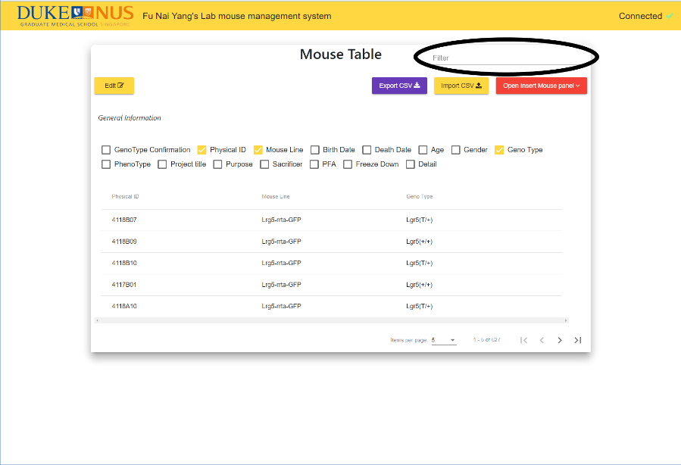

If particular mouse has either PFA information or FreezeDown information, a view buttons will be appeared at that row in the table on the detail column. (Tick the Detail checkbox to on the column)

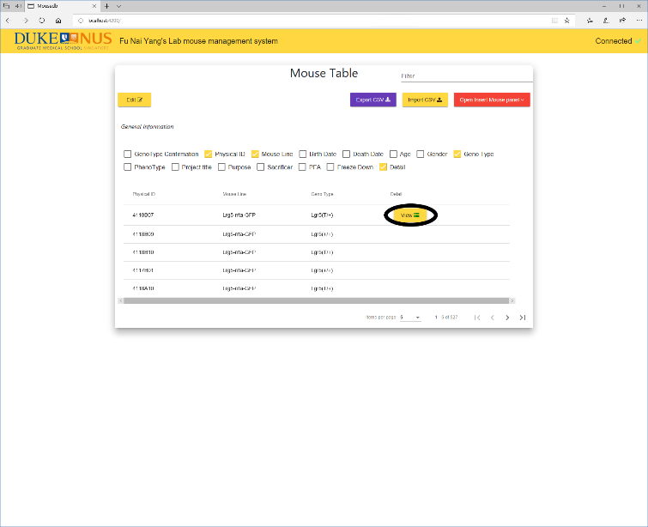

Notes:

The ordering of the table, on and off of the column and the filtering will be effective on the exported data.

1. Users can import their own mouse data in the formatted csv file. Users can upload more than one csv file at the same time.

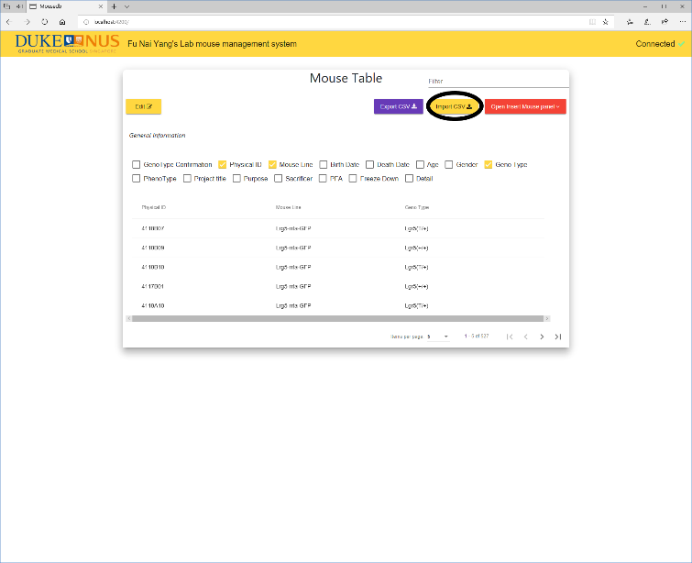

1. Users can export the table by clicking the export csv buttons

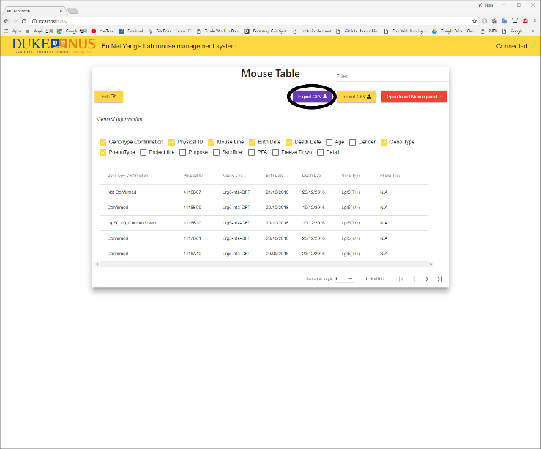

1. Users cam update the mouse under edit mode which can be enabled by clicking the edit buttons on the left up corner.

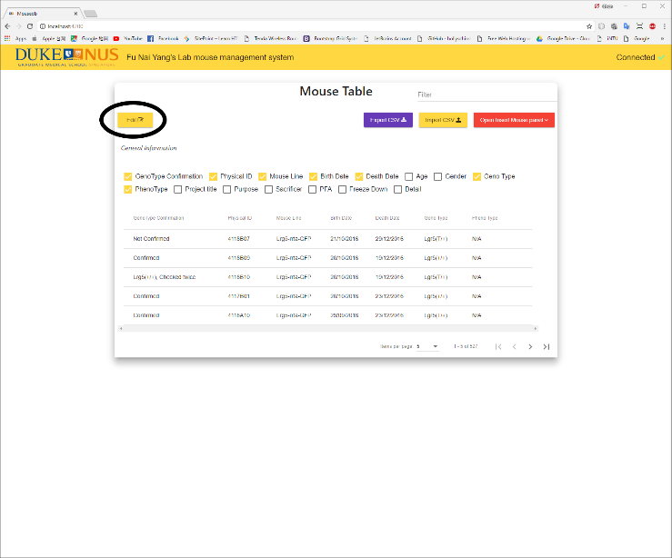

A checkbox will be turned on at the leftmost column. By clicking the confirm button, edit mouse panel will be appeared for each of mouse user had selected. Once user has successfully updated one of the mouse, that particular panel will be closed automatically. By clicking cancel edit buttons, all the edit mouse panel will be closed.

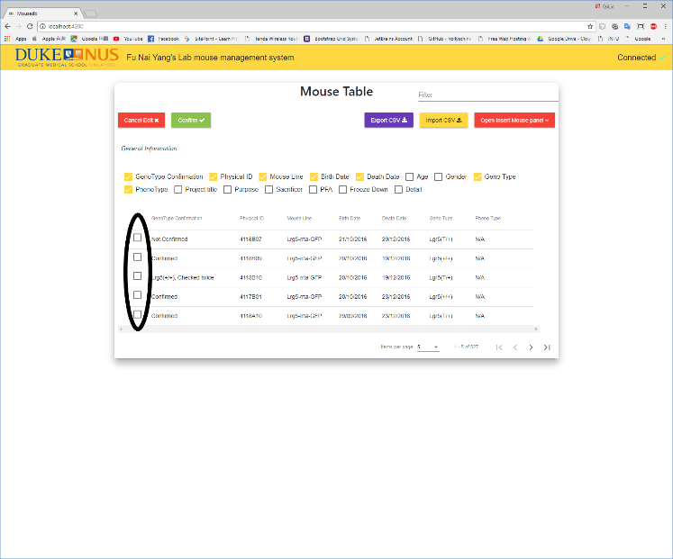

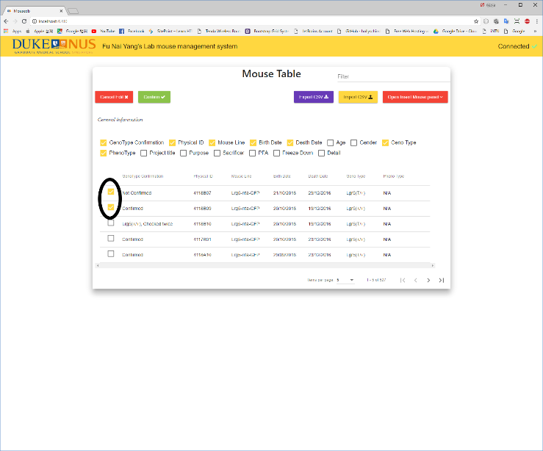

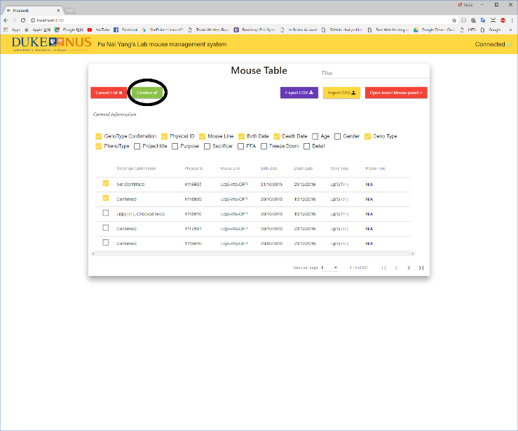

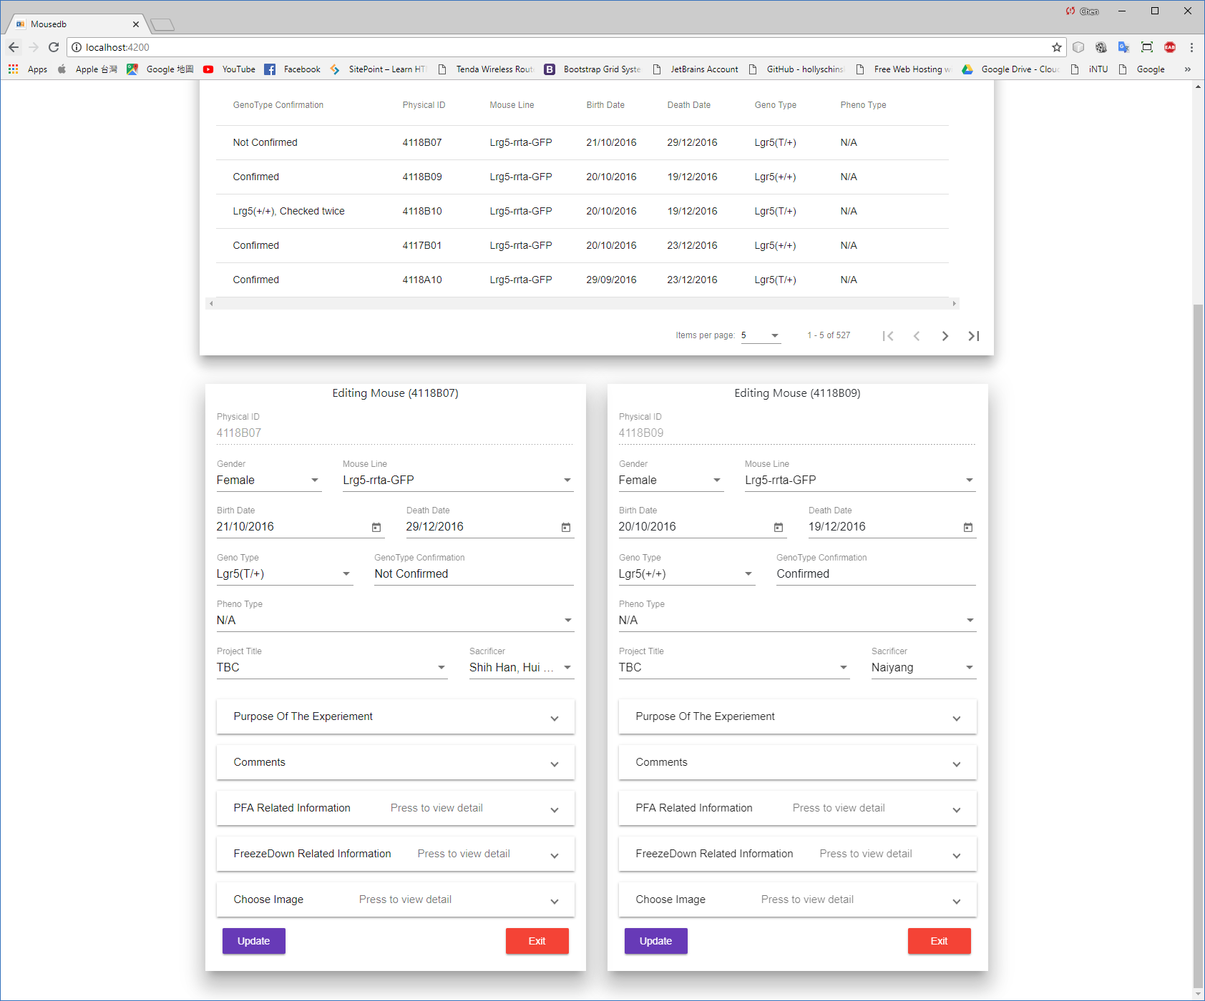

4. Uploading images of particular mouse can be done in two ways. Firstly, user can upload the image via the edit mouse panel under choose image section. The other way is via the viewing image panel which can be opened by double clicking the row of the table.